CS 255 System Design Document Template

UML Diagrams

UML Use Case Diagram
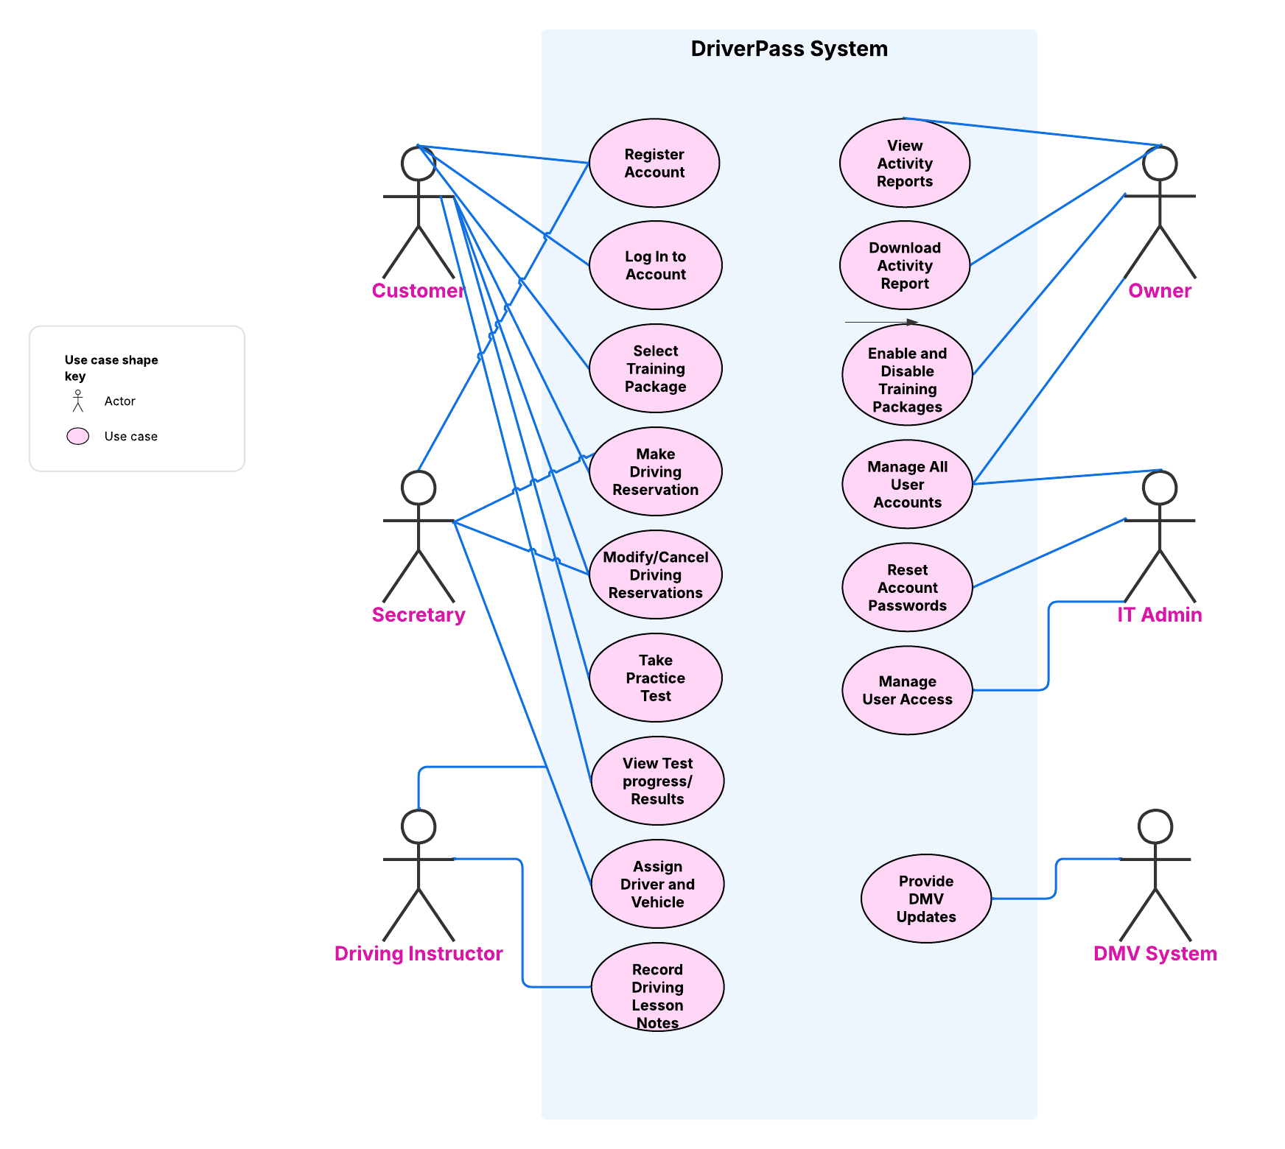

UML Activity Diagrams
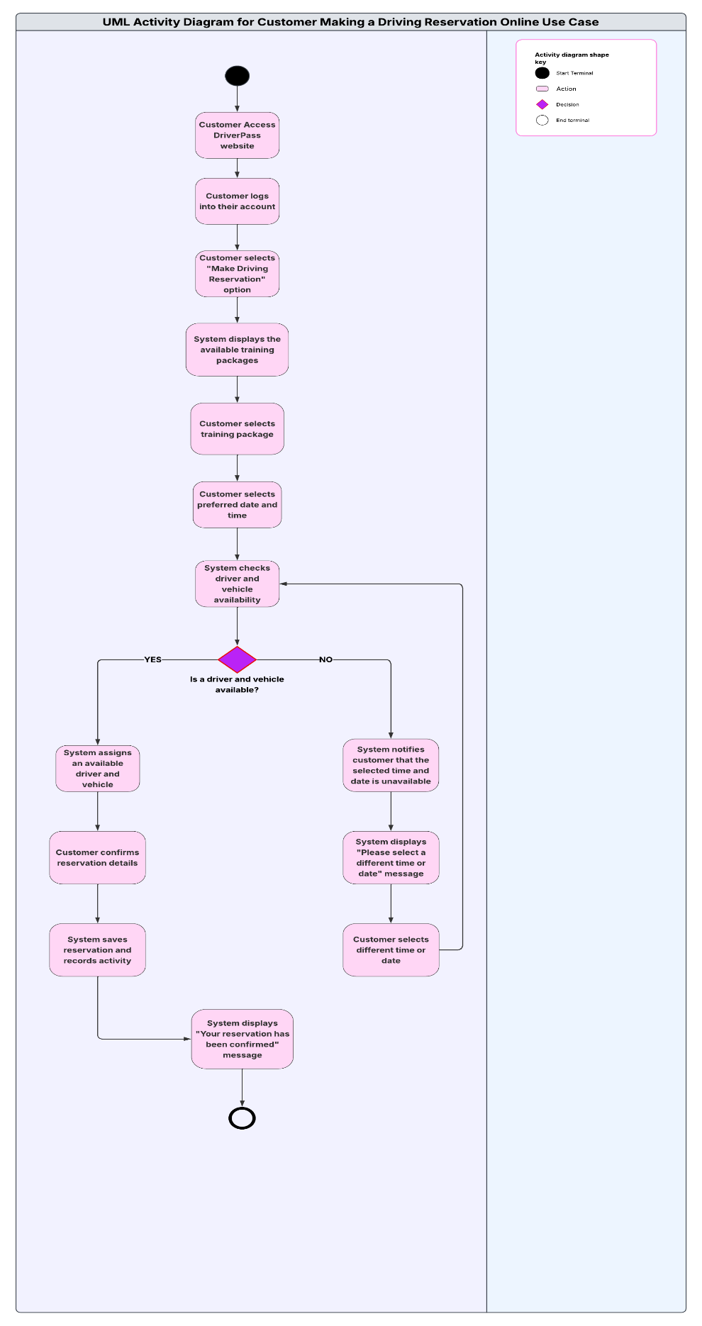
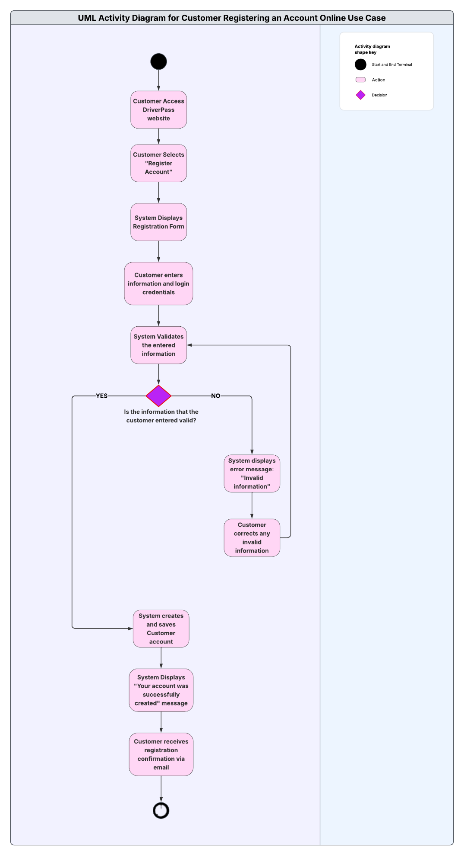

UML Sequence Diagram
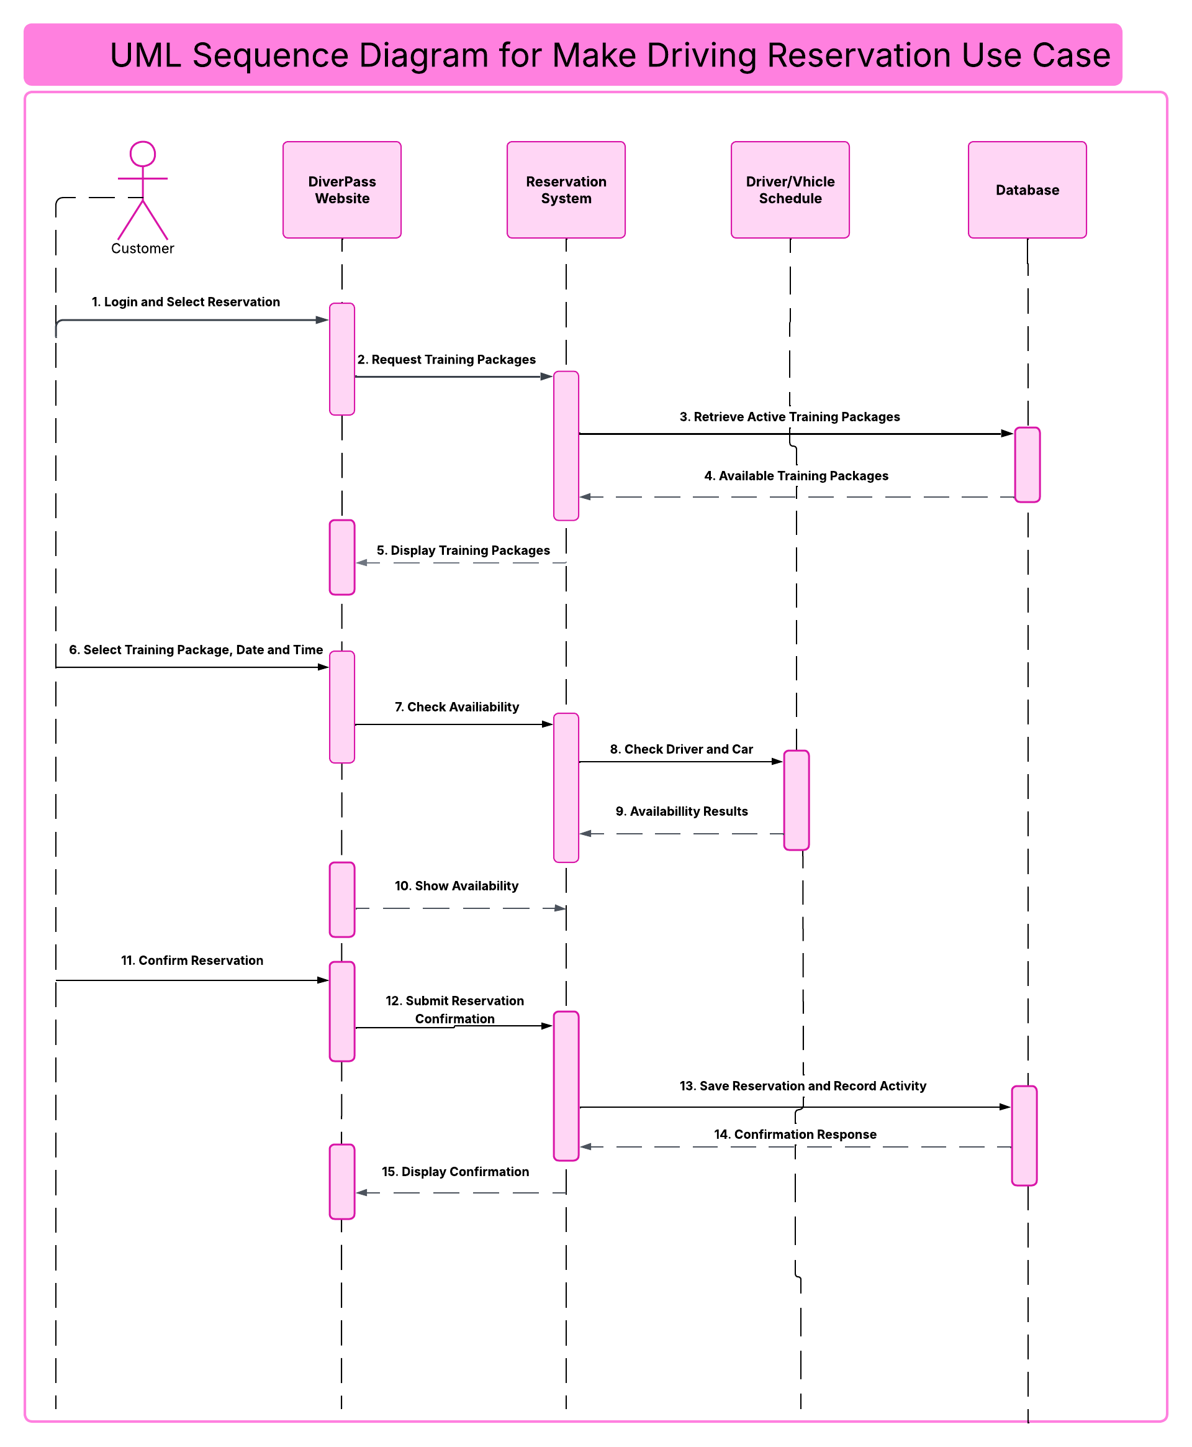

UML Class Diaggram

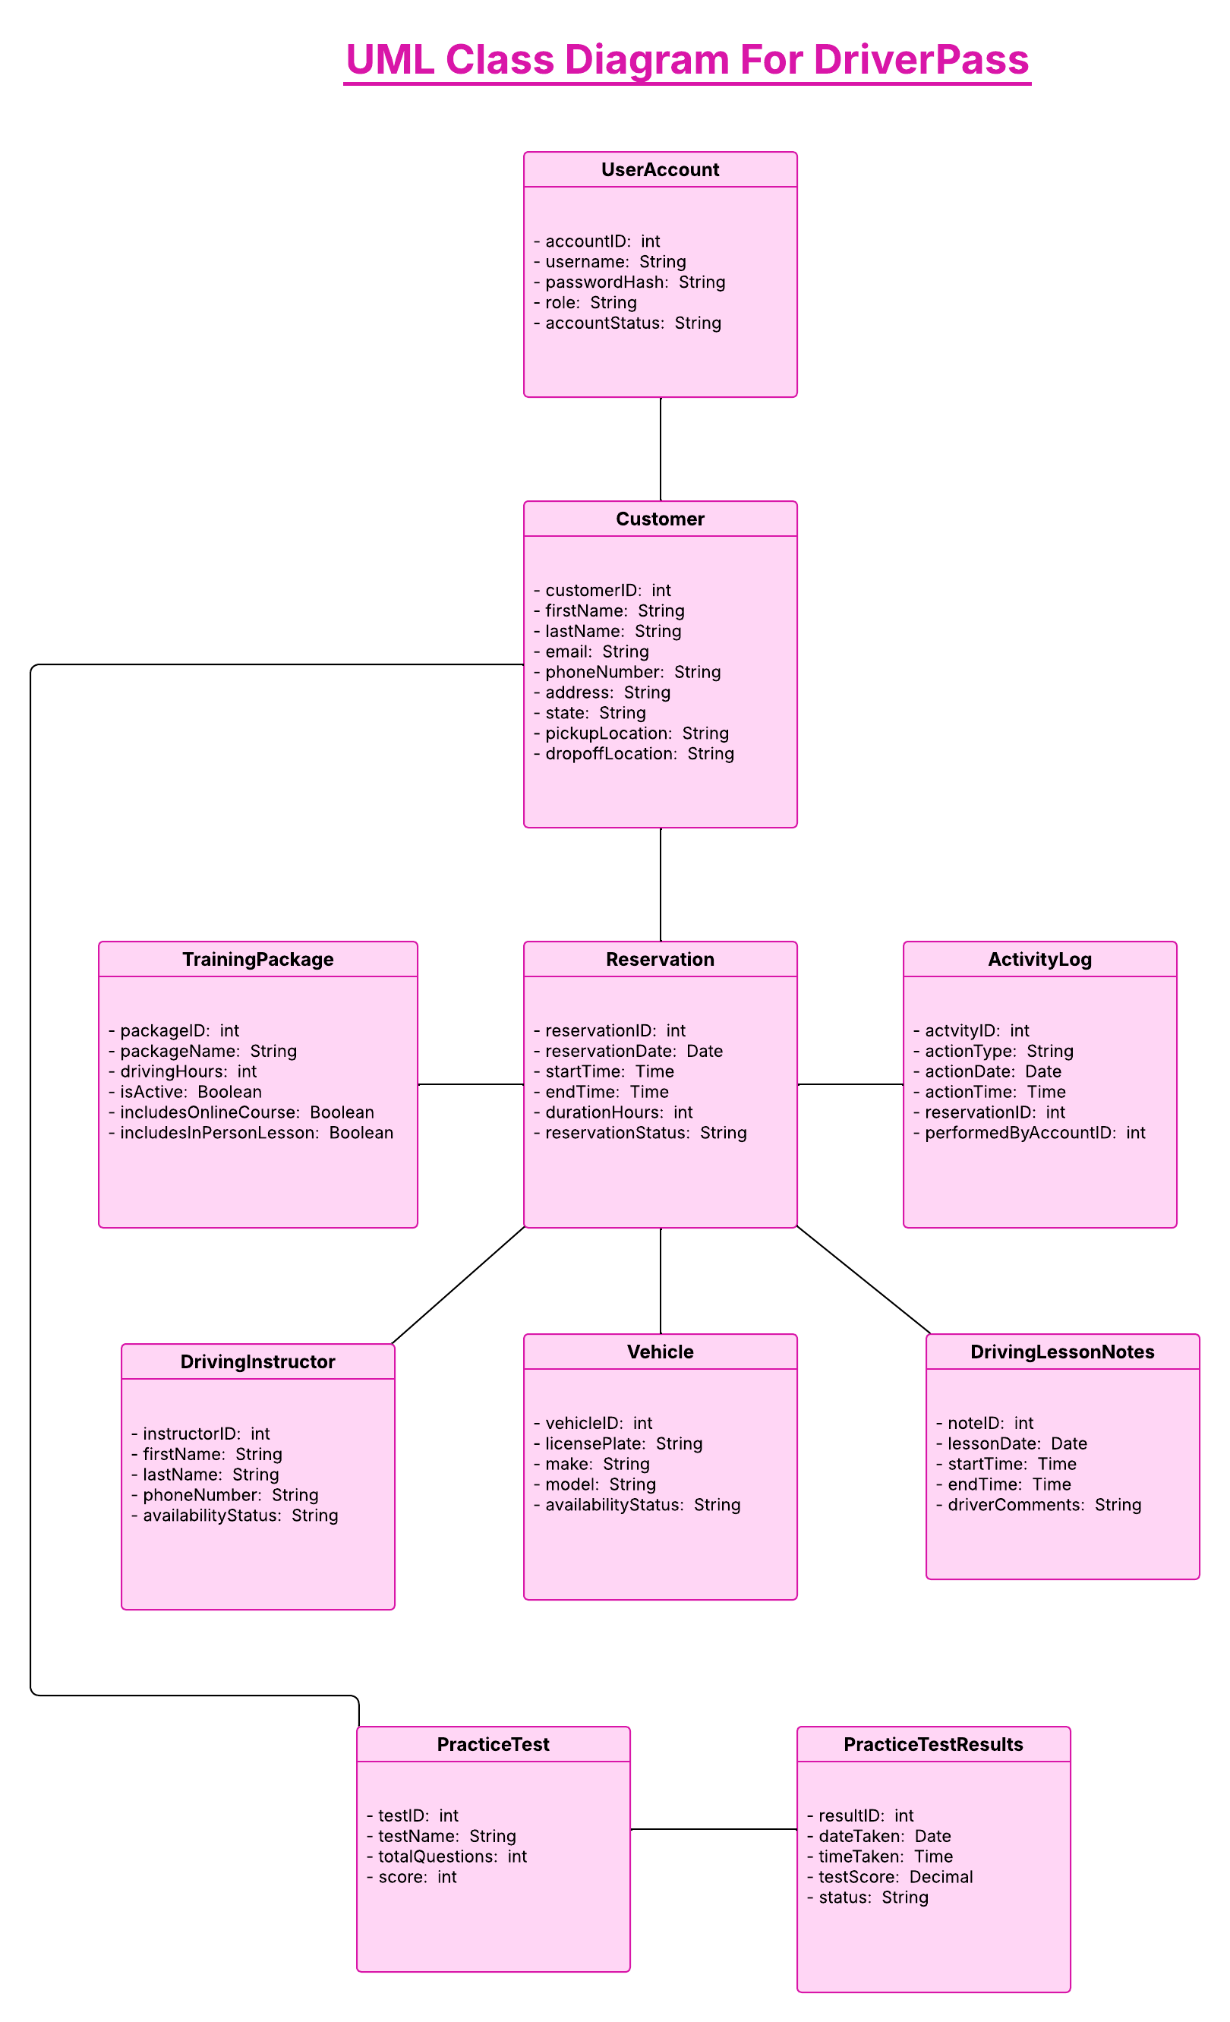

Technical Requirements

Hardware Requirements:
- The DriverPass system will require mobile devices such as computers, laptops, tablets or smartphones along with a reliable internet connection that will allow the users to access the web-based platform.
- Since the DriverPass system will be operating through a cloud-based platform, the cloud service provider will supply the server infrastructure that is needed to host the application and store the company’s data.
- The users such as the Secretary, driving instructors, owner and IT Admin will require access to compatible mobile devices such as computers and tablets to perform their assigned responsibilities such as scheduling reservations, recording driving lesson notes, reviewing activity reports and managing user accounts.
- Since the company will also have a physical office, additional devices such as computers, fax machines, scanners and printers will be needed to print activity reports and other important business documents when necessary.

Software Requirements:
- The DriverPass system should operate as web-based application that is accessible and compatible with commonly used web browsers such as Google Chrome and Microsoft Edge without requiring users to install additional software.
- Microsoft Azure is the proposed cloud hosting platform for the DriverPass system. Microsoft Azure will reduce the company’s responsibility of maintaining physical servers while allowing the company to access its data online.
- Azure SQL Database is the proposed database for the DriverPass system that will be used to store and manage customer data, employee accounts, training packages, driving reservations, assigned driving instructors and vehicles, practice test results and activity records.
- The DriverPass system should support software that allows authorized employees to download reports from Microsoft Excel, review these reports and work with the data offline.
- The DriverPass system should support software that receives updates from the DMV such as any updated rules, policies and sample questions so that the company’s training materials remain current.

Tools Requirements:
- The development team will require both programming and database management tools to create, test, support and maintain the DriverPass web application and its database.
- Various testing tools such as Playwright, Jest, Postman, Apache JMeter and BrowserStack will be necessary for the development team to verify that all functions such as customer registration, account authentication, driving reservations and practice tests operate correctly.
- Security Testing tools such as OWASP ZAP will be necessary to identify any vulnerabilities and verify that both the customer and employee’s data are properly protected within the system.
- The DrivrPass system will also require monitoring and reporting tools such as new Relic, Pingdom and Microsoft Power BI that will assist the IT Admin to identify any system errors and maintain the performance of the DriverPass application.
- The web-based application Lucidchart will be used to create the different UML use cases, UML activity, UML sequence and UML class diagrams during the system design process. These diagrams play a vital role in the design process system as they help the development team to understand what functions and components should be integrated in the system to meet the requirements of the owner of DriverPass.

Infrastructure Requirements:
- The DriverPass system should use a cloud-based infrastructure such as Microsoft Azure to support online access, data storage, security management and provide system backups.
- A reliable internet connection will be required for the users to access and interact with the system. Downloaded activity reports will be able to be accessed offline but any changes or updates to the system’s database will require a reliable internet connection.
- The DriverPass system should integrate role-based authorization to ensure that the users of the system can access only the data and functions that are needed to complete their responsibilities.
- The DriverPass system must protect the customer data and other sensitive data through encryption during transmission and storage. User passwords should be securely stored, and the system should integrate a security feature that temporarily restricts access after three failed login attempts to reduce the risk of unauthorized access.
- The DriverPass system should maintain the activity records by making a record of who created, modified, or canceled a driving reservation.
- The cloud-based provider should include automated backups and recovery capabilities to protect the company’s data from unexpected system failures or data loss.
- The DriverPass system should be designed to support scalability so that any future modifications and additional features can be integrated into the current system without requiring the development of new system. This will allow DriverPass to expand it’s services as the company’s needs change.

